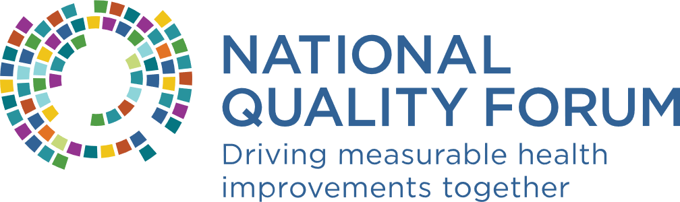 Breakout Room Worksheet

# Leveraging Electronic Health Record (EHR) Sourced Measures to Improve Care Communication and Coordination Option Year

# Web Meeting 3

The Base Year of the Leveraging Electronic Health Record (EHR) Sourced Measures to Improve Care Communication and Coordination project described the current state of using EHRs to measure and improve care communication and care coordination. The Option Year will build on this work to develop recommendations for facilitating and improving EHR-based care communication and care coordination measurement in an all-payer, cross-setting, and fully electronic manner to drive quality improvement and outcomes. Recommendations will be provided for:

1. How EHRs could better facilitate care communication and care coordination
2. Addressing social determinants of health (SDOH) data collected by EHRs as it relates to care communication and care coordination
3. How existing and future development of EHR-sourced measures can be leveraged to improve care communication and care coordination
4. Possible EHR-sourced measure concepts related to care communication and care coordination

These recommendations will be conveyed in two Final Recommendations Reports (a long, technical version and a shortened, non-technical version).

## SDOH Data Impacts on EHR-Based Care Communication and Care Coordination

Below, we briefly describe several of the important technical issues and programs relevant to SDOH data and EHR-based care communication and care coordination: Health Level Seven (HL7), Fast Healthcare Interoperability Resources (FHIR), and the Gravity Project, which is directly relevant to SDOH. The purpose is to provide basic background information to the Committee with varied experience and expertise in health information technology (IT) and these programs.

HL7 FHIR establishes data standards and representational state application programming interfaces (API) to provide guidance for transferring and sharing data between multiple healthcare providers. The adoption of these data standards supports clinical practice and the management, delivery, and evaluation of health services. Both the Office of the National Coordinator for Health Information Technology (ONC) and the Centers for Medicare & Medicare Services (CMS) have rules that are requiring implementation of FHIR-based APIs to support the sharing of health information and this implementation will also help move the field towards digital quality measurement.

The [Gravity Project](https://www.hl7.org/gravity/) is an HL7 FHIR Accelerator project that is actively developing consensus-based definitions and standardized data sets for various SDOH data in EHRs using identified coded data elements. The intent of the Gravity Project is not to redefine these SDOH data elements, rather it identifies existing definitions, data elements, and tools that can be used within the EHR. The Gravity Project’s multistakeholder members first identify common data elements and associated value sets for documenting different SDOH data (e.g., by different social risk domains, outlined below) in EHRs. Consensus-based recommendations are then developed about how to best capture and group these data elements for interoperable electronic exchange and aggregation. If gaps in coding are identified, the Gravity Project collaborates with coding and terminology suppliers [e.g., International Classification of Diseases Tenth Revision (ICD-10), Logical Observation Identifiers Names and Codes (LOINC), and Systemized Nomenclature of Medicine – Clinical Terms (SNOMED)] to address the gaps. The codes for SDOH data sets are developed and tested for use in FHIR and then an FHIR Implementation Guide is developed.

For each social risk domain, [terminology workstreams](https://confluence.hl7.org/display/GRAV/Terminology+Workstream+Dashboard) will create data sets across four clinical activities: screening, diagnosis, goal setting, and interventions. The Gravity Project tracks the [status of domain specific codes](https://confluence.hl7.org/display/GRAV/SDOH+Data+Elements+And+Status) across the four clinical activities. The status of the domain specific codes ranges from having a comprehensive list of codes for each activity (e.g., food insecurity) to not yet having developed a list of codes for any activity (e.g., elder abuse). This [master list of codes](https://confluence.hl7.org/download/attachments/91994432/05142021%20Food%20Insecurity%20MASTER.xlsx?api=v2) for the Food Insecurity domain is an example of the outputs from the Gravity Project. It includes the codes for identified food insecurity-related screening questions and answers, diagnoses, and planned interventions.

The intent of **Web Meeting 3 (February 8, 2022)** **is to discuss the impact SDOH data could have on EHR-based care communication and care coordination and develop recommendations for how SDOH data can be used for care communication and care coordination quality measurement.** Specifically, the Committee breakout groups will discuss the impact the Gravity Project could have on EHR-based care communication and care coordination, data collection considerations when implementing these data sets, and how these data sets may be useful for quality measurement (e.g., use related to risk stratification or for the development of measure concepts).

### Gravity Project Social Risk Domains

* [Demographics](https://confluence.hl7.org/display/GRAV/Demographics+Domain): Includes the following domains:
  + Educational Attainment – Less than high education definition: Failing to meet academic criteria for high school diploma or equivalent
  + Employment Status – Unemployment definition: Jobless, looking for a job, and available for work
  + Veterans Status – Veteran definition: Having served as active military and honorably released or discharged
* [Elder Abuse](https://confluence.hl7.org/display/GRAV/Elder+Abuse)
* [Financial Insecurity](https://confluence.hl7.org/display/GRAV/Financial+Insecurity): A state of being wherein a person has difficulty fully meeting current and/or ongoing financial obligations and/or does not feel secure in their financial future.
* [Food Insecurity](https://confluence.hl7.org/display/GRAV/Food+Insecurity): Uncertain, limited, or unstable access to food that is: adequate in quantity and in nutritional quality; culturally acceptable; safe and acquired in socially acceptable ways
* [Housing Instability and Homelessness](https://confluence.hl7.org/display/GRAV/Housing+Instability+and+Homelessness)
* [Inadequate Housing](https://confluence.hl7.org/display/GRAV/Inadequate+Housing): Housing does not meet habitability standards
* [Intimate Partner Violence](https://confluence.hl7.org/display/GRAV/Intimate+Partner+Violence)
* [Material Hardship](https://confluence.hl7.org/display/GRAV/Material+Hardship): The lack of specific socially perceived based physical necessities.
* [Social Connection](https://confluence.hl7.org/display/GRAV/Social+Connection): The type, size, closeness, and frequency of contacts in a respondent’s current social network.
* [Stress](https://confluence.hl7.org/display/GRAV/Stress): Occurs when a person perceives the demands of environmental stimuli to be greater than their ability to meet, mitigate, or alter those demands.
* [Transportation Insecurity](https://confluence.hl7.org/display/GRAV/Transportation+Insecurity): Uncertain, limited, or no access to safe, reliable, accessible, affordable, and socially acceptable transportation infrastructure and modalities necessary for maintaining one’s health, well-being, or livelihood.

## Discussion Questions

In breakout groups during Web Meeting 3, the questions below should be used to help facilitate the discussion. **Prior to the meeting, please consider the following questions and come prepared to share your responses.**

| Question | Responses |
| --- | --- |
| What impact could the Gravity Project have on EHR-based care communication and care coordination? | *Please include ideas here* |
| What data collection considerations should be included when implementing these definitions in EHRs (e.g., data provenance, data accuracy, collection burden)? | *Please include ideas here* |
| How should these SDOH data be used for care communication and care coordination quality measurement (e.g., risk stratification, risk adjustment, new measure concepts)? | *Please include ideas here* |
| What other SDOH data beyond the Gravity Project could be used for care communication and care coordination quality measurement? | *Please include ideas here* |